NEWS LETTER 2022-23

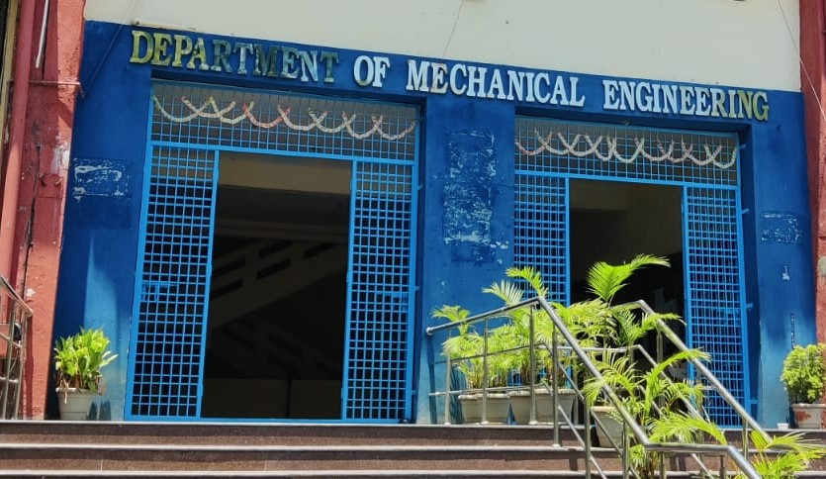

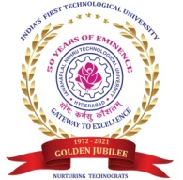

Center for Energy Studies
Department of Mechanical Engineering
JNTUH COLLEGE OF ENGINEERING HYDERABAD (AUTONOMOUS)
KUKATPALLY, HYDERABAD-500085

FACULTY NAME DESIGNATION
Dr. Dr. M.T. Naik Professor & Coordinator
Dr. K. V. Sharma Emeritus Professor

TEACHING STAFF
ASSISTANT PROFESSORS (CONTRACT)

Mrs. Ch. Anjamma (Guest Faculty)
Mr. P.S. Vijay Sagar

NON-TEACHING STAFF

LABORATORY STAFF
Mr. G. Kanthaiah | Technical Assistant
ADMINISTRATIVE STAFF
G.Sreedevi | Computer Operator
N. Shashi Kumar | Attender

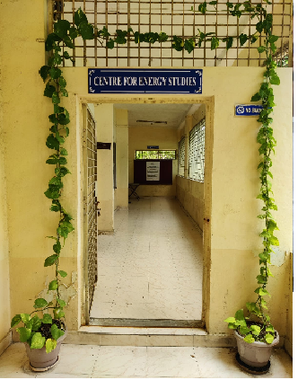
ABOUT THE CENTER FOR ENERGY STUDIES
Energy availability at economic cost is the driving force for any economy. In recent years, the growth in the industrial/service sector has resulted in enhanced energy consumption widening the gap between the energy demand and supply. Energy conservation has attained priority as it is regarded as an additional energy resource. A few organizations engaged in the field of energy studies confined their activities to the area of consultancy. Realizing this limitation, the School of Energy was established by the University in the year 1989.
Before starting the School of Energy, the University offered a five-semester part-time program in Energy Management. The academic Link Interchange scheme (ALIS) existed with the Scottish Energy Centre (SEC) at Napier Polytechnic, Edinburgh, U.K, in collaboration with the British Council Division, Madras. The outcome of ALIS was establishing the School of Energy in 1989 with the expertise of core faculty drawn from the constituent units of the University. The School of Energy commenced a 3-semester M.Tech program in Energy Systems in 1990. The school was later renamed the Center for Energy Studies (CES) in 1996. The Centre was brought under the administration of the College in 2003.

VISION and MISSION of the CENTER
- To provide quality education for graduate students by disseminating knowledge in inter disciplinary areas of science and technology
- To carry out both basic and applied research in solving diverse problems in energy sector
- To develop innovative measures leading to technology up gradation and energy conservation
- To undertake development, testing and transfer of technology to stake-holders for sustainable development
- Act as a nodal Centre for promoting sponsored research and industrial consultancy

FACULTY PROFILES
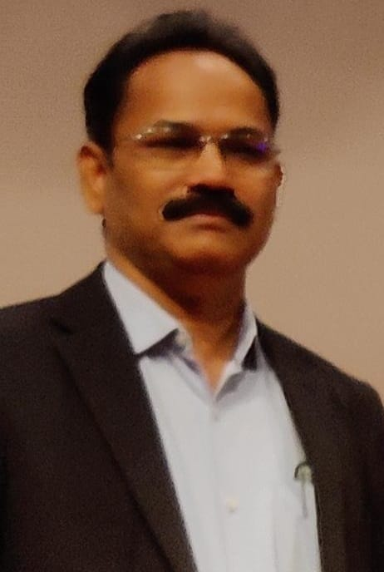
Dr. M.T. Naik
B. Tech, M.Tech, Ph. D
Professor
Prof.M.T.Naik completed his B.Tech, M.Tech and Ph.D in the Mechanical Engineering from Jawaharlal Nehru Technological University Hyderabad. He joined in JNTUH as Lecturer of Mechanical Engineering in the year 1994.He was promoted as Associate Professor in the year 2003 and since 2011 he has been working as Professor. His research areas include heat transfer in nanofluids, Renewable energy Technologies and optimization of Energy systems. He has published about60 research articles in reputed international Journals.He has h-Index score is 12 and more than 1000 citations for the research articles. He guided four Ph.D students and supervising four more research scholars.
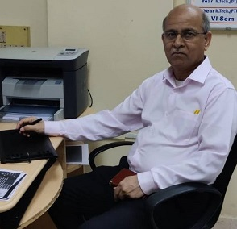
Dr. K.V. Sharma
ME (Andhra University), Ph.D (JNTU)
FIE, MISTE, ISHMT, HESI
1. Ph.D in Mechanical Engineering, Jawaharlal Nehru Technological University, Hyderabad with First (1995-2000)
2. M.E in Mechanical Engineering, Andhra University with First (1982-1985)
3. B.Tech in Mechanical Engineering, Jawaharlal Nehru Technological University, Hyderabad with First (1977-1982)
Areas of Interest:
Single Phase Convection, Heat Transfer Enhancements with Nanofluids and Inserts, Computer Assisted Numerical Analysis, Numerical Simulation, Pool Boiling Heat Transfer, Solar thermal energy Conversion, Electronic Component Cooling, Packed Bed Heat Transfer, Heat Exchangers

LABORATORY EQUIPMENTS
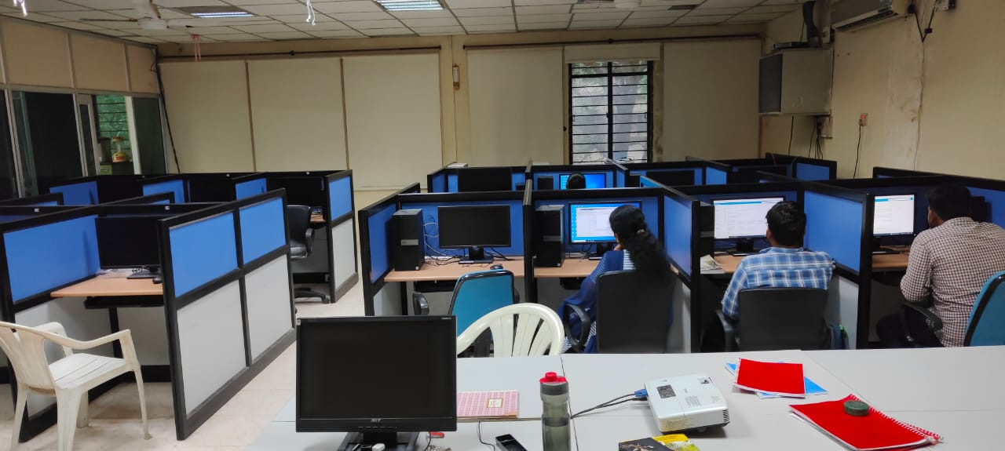

The Computer systems procured in the year 2009 were refurbished in 2018 with the procurement of 12 systems. With the introduction of Model Curriculum, due to increase in the useage of Computer usage, the laboratory is refurbished with the procurement of 10 systems.
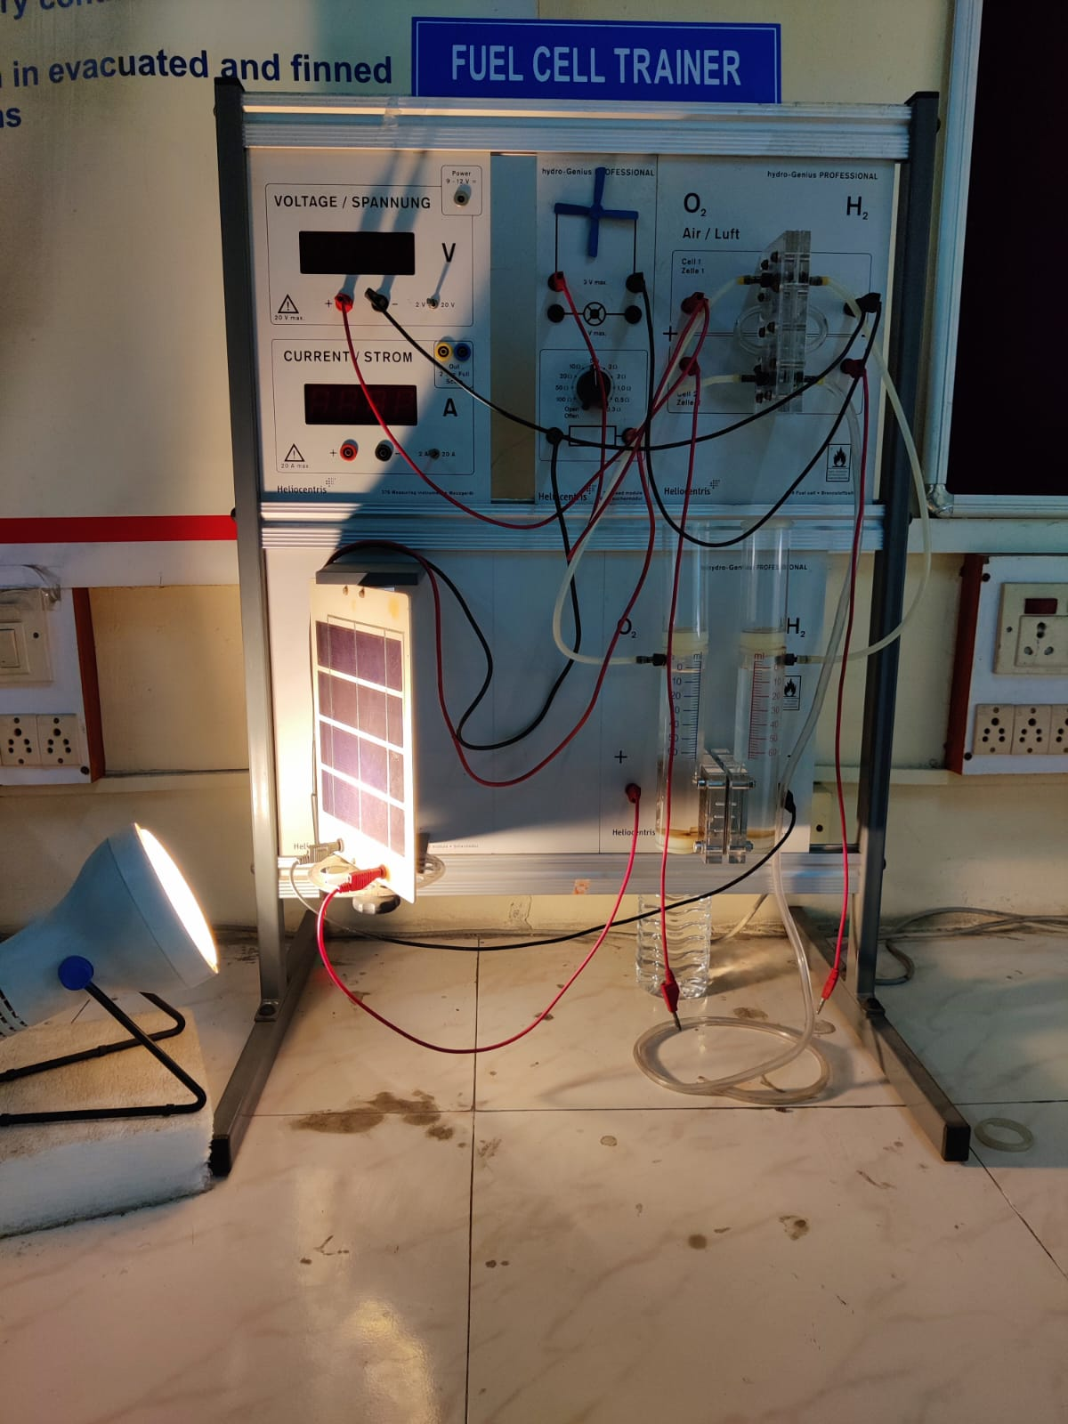

A fuel cell trainer generates DC current when connected to a P.V.Panel powered by a light source. The current generated electrolyze water dissociating oxygen and hydrogen. The ionized gases recombine to form water and the electrons flow through the load. It is connected to a DC fan load which rotates.

PUBLICATIONS
- Dr. M. T. Naik, “Analysis of Twisted Vertical Axis turbine blade of NACA4-series-Experimental approach”, AIPCP, April 2022.
- B. Saleh, L. Syam Sundar, Ayman A. Aly, E. Venkata Ramana, K. V. Sharma, Asif Afzal, Yasser Abdelrhman, Antonio C. M. Sousa, “The Combined Effect of Al2O3 Nanofluid and Coiled Wire Inserts in a Flat-Plate Solar Collector on Heat Transfer, Thermal Efficiency and Environmental CO2 Characteristics” Arabian Journal for Science and Engineering, (2022). https://doi.org/10.1007/s13369-021-06478-7.
- P Kanti, K. V. Sharma, Zafar Said, Mehdi Jamei, Kyathanahalli Marigowda Yashawantha, "Experimental investigation on thermal conductivity of fly ash nanofluid and flyash-Cu hybrid nanofluid: prediction and optimization via ANN and MGGPm odel" Particulate 4|Page Science and Technology, (2022) Vol.40, No.2, 182- 195, https://doi.org/10.1080/02726351.2021.1929610
- Praveen Kumar Kanti, Elena Ionela Chereches, Alina Adriana Minea, K. V. Sharma, “Experiments on thermal properties of ionic liquid enhanced with alumina nanoparticles for solar applications”, Journal of Thermal Analysis and Calorimetry, 2022, DOI: 10.1007/s10973-022-11534-x
- Praveen Kanti, Alina Adriana Minea, K.V.Sharma, M.Revanasiddappa, Improved thermophysical properties of Graphene Ionanofluid as heat transfer fluids for thermal applications, Journal of Ionic liquids 2022, https://doi.org/10.1016/j.jil.2022.100038
- Praveen Kanti, K.V. Sharma, Rohit S. Khedkar, Tauseef-ur Rehman, Synthesis, characterization, stability, and thermal properties of graphene oxide-based hybrid nanofluids for thermal applications: Experimental approach, Diamond and Related Materials, 2022, https://doi.org/10.1016/j.diamond.2022.109265
- T. Rajendra Prasad, K. Rama Krishna, K.V. Sharma, N. Mantravadi, Viscosity and thermal conductivity of Cobalt and Silica nanofluid in an optimum mixture of glycerol and water, Colloidal Journal, 2022, DOI: 10.1134/S1061933X22020090
- P. H. V. SeshaTalpa Sai, M. L. R. Chaitanya Lahari, K. V. Sharma, K. S. Narayanaswamy, Counterflow HE analysis of Cu and SiO2 nanofluids in the developing flow region, Heat Transfer, 2022.https://doi.org/10.1002/htj.22459

