NEWS LETTER 2021-22

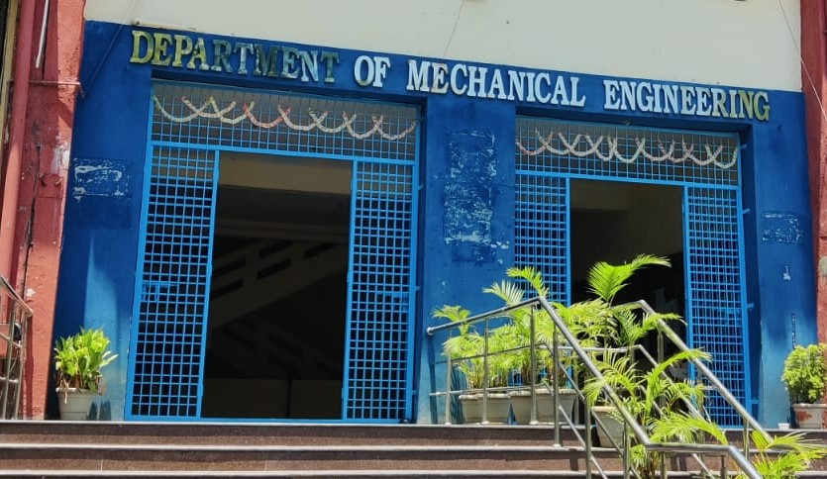
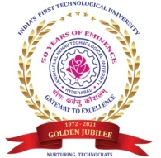

Center for Energy Studies
Department of Mechanical Engineering
JNTUH COLLEGE OF ENGINEERING HYDERABAD (AUTONOMOUS)
KUKATPALLY, HYDERABAD-500085

FACULTY NAME DESIGNATION
Dr. Dr. M.T. Naik Professor & Vice Principal
Dr. K. V. Sharma Emeritus Professor

TEACHING STAFF
ASSISTANT PROFESSORS (CONTRACT)

Mrs. Ch. Anjamma (Guest Faculty)
Mr. P.S. Vijay Sagar

NON-TEACHING STAFF

LABORATORY STAFF
Mr. G. Kanthaiah | Technical Assistant
ADMINISTRATIVE STAFF
G.Sreedevi | Computer Operator
N. Shashi Kumar | Attender

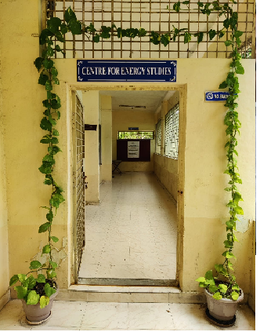
ABOUT THE CENTER FOR ENERGY STUDIES
Energy availability at economic cost is the driving force for any economy. In recent years, the growth in the industrial/service sector has resulted in enhanced energy consumption widening the gap between the energy demand and supply. Energy conservation has attained priority as it is regarded as an additional energy resource. A few organizations engaged in the field of energy studies confined their activities to the area of consultancy. Realizing this limitation, the School of Energy was established by the University in the year 1989.
Before starting the School of Energy, the University offered a five-semester part-time program in Energy Management. The academic Link Interchange scheme (ALIS) existed with the Scottish Energy Centre (SEC) at Napier Polytechnic, Edinburgh, U.K, in collaboration with the British Council Division, Madras. The outcome of ALIS was establishing the School of Energy in 1989 with the expertise of core faculty drawn from the constituent units of the University. The School of Energy commenced a 3-semester M.Tech program in Energy Systems in 1990. The school was later renamed the Center for Energy Studies (CES) in 1996. The Centre was brought under the administration of the College in 2003.

VISION and MISSION of the CENTER
- To provide quality education for graduate students by disseminating knowledge in inter disciplinary areas of science and technology
- To carry out both basic and applied research in solving diverse problems in energy sector
- To develop innovative measures leading to technology up gradation and energy conservation
- To undertake development, testing and transfer of technology to stake-holders for sustainable development
- Act as a nodal Centre for promoting sponsored research and industrial consultancy

FACULTY PROFILES

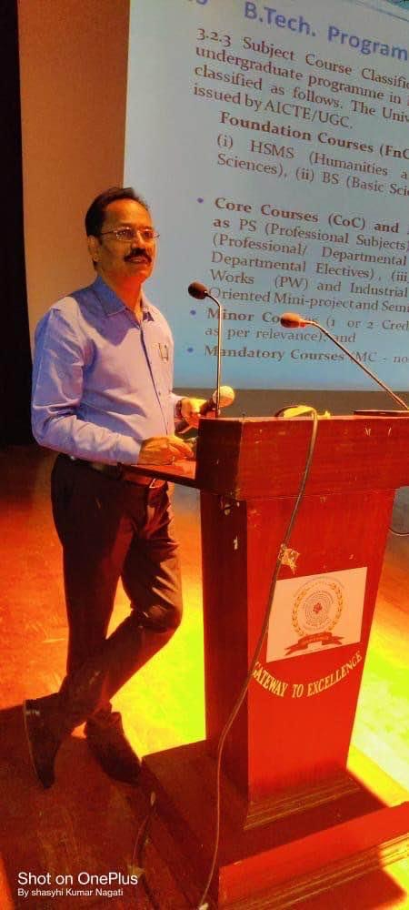

Dr. M.T. Naik
B. Tech, M.Tech, Ph. D
Professor
Prof.M.T.Naik completed his B.Tech, M.Tech and Ph.D in the Mechanical Engineering from Jawaharlal Nehru Technological University Hyderabad. He joined in JNTUH as Lecturer of Mechanical Engineering in the year 1994.He was promoted as Associate Professor in the year 2003 and since 2011 he has been working as Professor. His research areas include heat transfer in nanofluids, Renewable energy Technologies and optimization of Energy systems. He has published about60 research articles in reputed international Journals.He has h-Index score is 12 and more than 1000 citations for the research articles. He guided four Ph.D students and supervising four more research scholars.

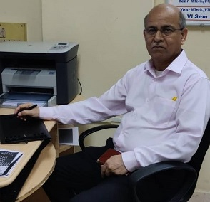
Dr. K.V. Sharma
ME (Andhra University), Ph.D (JNTU)
FIE, MISTE, ISHMT, HESI
Energy Systems
1. Ph.D in Mechanical Engineering, Jawaharlal Nehru Technological University, Hyderabad with First (1995-2000)
2. M.E in Mechanical Engineering, Andhra University with First (1982-1985)
3. B.Tech in Mechanical Engineering, Jawaharlal Nehru Technological University, Hyderabad with First (1977-1982)

Areas of Interest:
Single Phase Convection, Heat Transfer Enhancements with Nanofluids and Inserts, Computer Assisted Numerical Analysis, Numerical Simulation, Pool Boiling Heat Transfer, Solar thermal energy Conversion, Electronic Component Cooling, Packed Bed Heat Transfer, Heat Exchangers.

Value Added Courses Offered:
Name of the value added courses | Course Instructors | Year | Code Year Duration of the course
Content Writing | Dr. M.T.Naik  Dr. K.V.Sharma | 2021-22 | 21.12.2020- 07.02.2021
Work Life Balance | Dr. K.V.Sharma  Dr. M.T.Naik | 2021-22 | 07.02.2022 - 12.03.2022
Employment Motivation | Dr. M.T.Naik  Dr. K.V.Sharma | 2021-22 | 16.05.2022 – 24.06.2022

Participate Students:
S.No | Student Name | Reg.no
1 | V. Navya Sree | 21011D1001
2 | D. Sanjana | 21011D1002
3 | M. Shivaprasad | 21011D1003
4 | M. Shashikumar | 21011D1004
5 | S. Sai Ganesh | 21011D1007
6 | B. Venugopal | 21011D1008
7 | K. Chandana | 21011D1010
8 | K. Srija | 21011D1011
9 | G. Shivateja | 21011D1013
10 | A.Anitha | 21011D1014

LABORATORIES EQUIPMENT
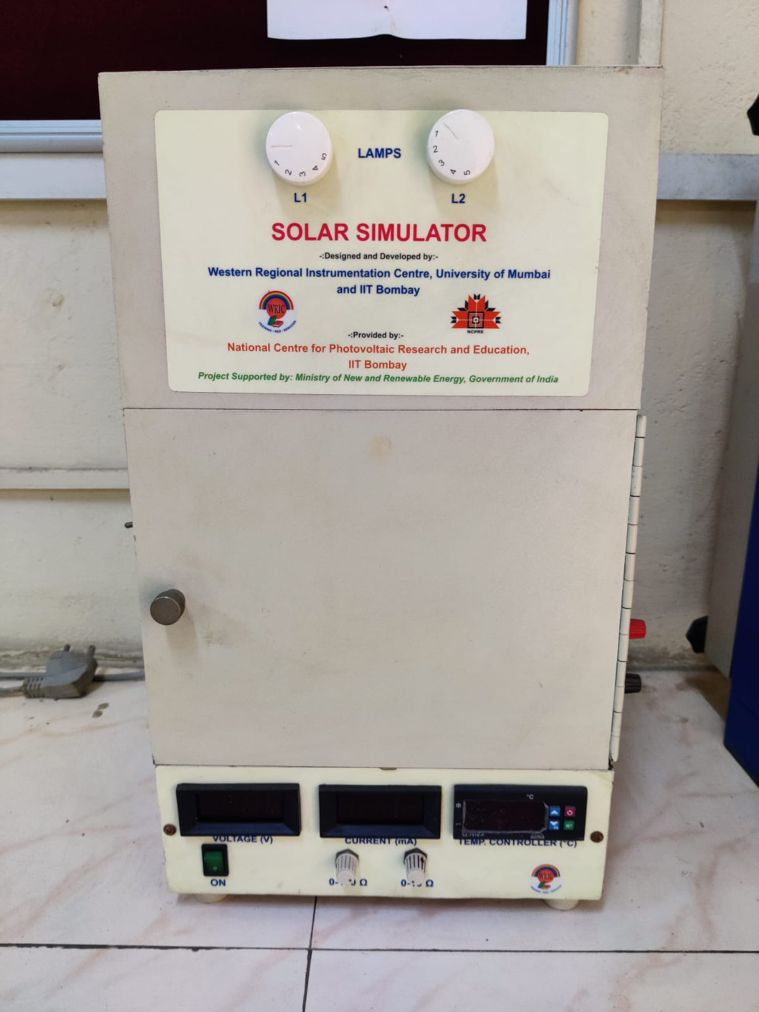
A small PV cell generates power with the aid of a light source. The power generated varies based on the wavelength of the source. The wavelength is varied through obstruction of the light with different colored sheets. The output power varies as certain wavelengths are filtered by these plastic sheets.

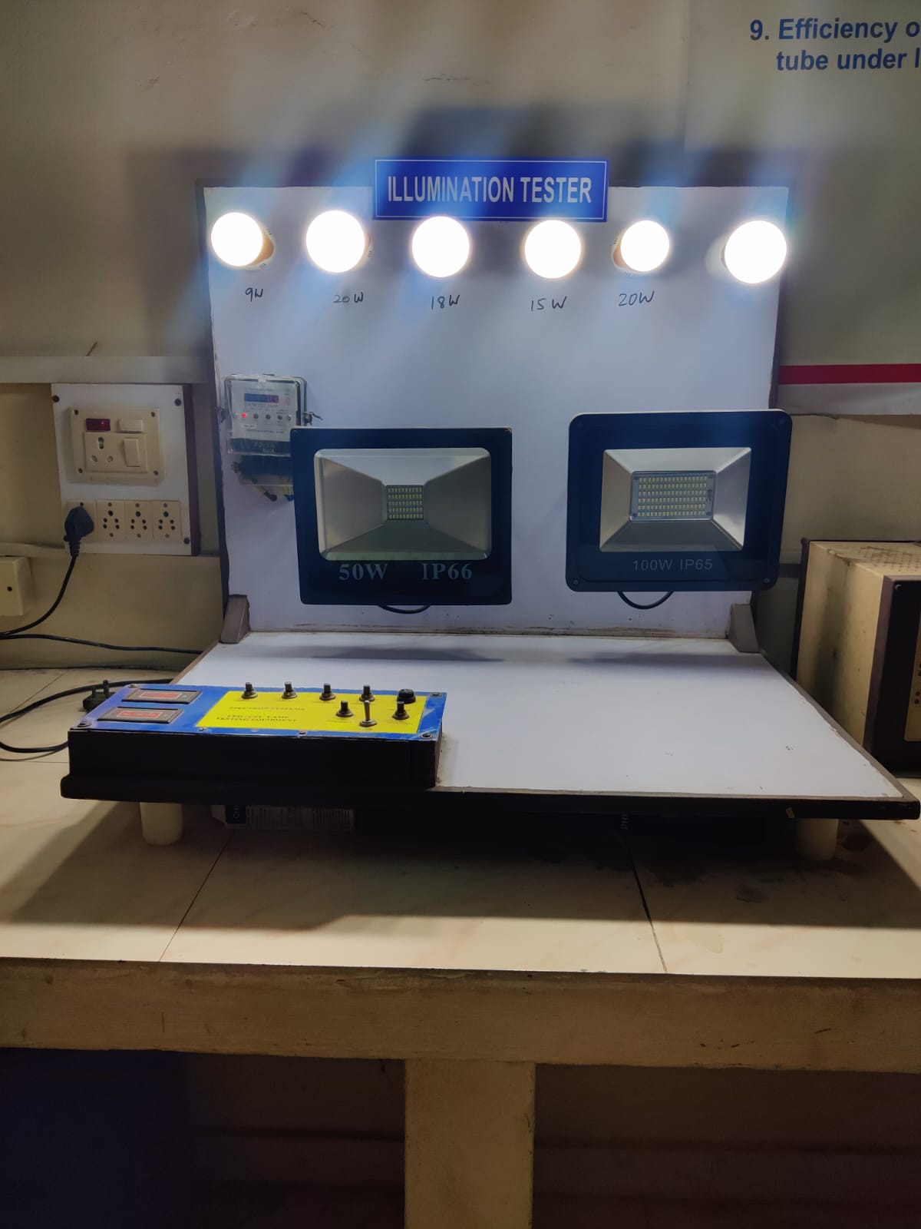

The amount of light that is cast on a surface is called illuminance, which is measured in 'Lux'. The total output of visible light from a light source is measured in lumens. One Lux is equal to one lumen per square meter. The further the light travels, the more it will be dispersed. The amount of lux in an area or on a surface can vary depending on the distance the light travels and the angle at which it is dispersed. Typically, more lumens a light fixture provides, the brighter it is. The setup is to demonstrate the conversion efficiency of the electrical energy into light form and to study the effect of distance from the light source.

PUBLICATIONS
- Dr. M. T. Naik, “Understanding frictional behavior of ASS316L in sheet metal forming”, Materials-today- proceedings, 2021 Jan 1 ISSN-2855-2858.
- Dr. M.T.Naik “Aerodynamic Shape Optimization of a Vertical Axis Wind Turbine NACAXXXX Series”, Journal of Resource Management and Technology (JRMAT) March 2021 Vol12, Issue3, 2021, 395-40, ISSN NO: 0745-6999.
- Dr. M.T. Naik, “Comparative analysis of low velocity vertical axis wind turbine NACA blades at different attacking angles in CFD , Materials Today ELSEVIER, August 2021.
ISSN NO: 2214-7853.

- Dr. M. T. Naik, “Evolution and Characterisation of ASS 316L at Elevated Temperature”, Advances in Materials and Processing Technologies, 2021 Jun 29, ISSN: 2374-0698
- Dr. M. T. Naik ,” Numerical Investigation of Baffle Spacing in a shell and Tube Heat Exchanger with Segmental Baffle”, International Journal of Applied Analysis Computation and Mathe material Modeling in Engineering.
- Dr. M. T. Naik “Comparison of performance with standard and twisted blades in VAWT”, Journal of Engineering Sciences (JES)Sep. 2021, ISSN: 20377-9254.
- 3. P Kanti, K. V. Sharma, KMYashawantha, M Jamei, Z Said, ”Properties of water-based fly ash-copper hybrid nanofluid for solar energy applications: Application of RBF model", Solar Energy Materials and Solar Cells 234, 111423.
- P Kanti, K. V. Sharma, Y Raja Sekhar, “Influence of particle size on thermal conductivity and dynamic viscosity of water‐based Indian coal fly ash nanofluid” Heat Transfer (Wiley) 51 (1), 413-433.
- P Kanti, K. V. Sharma, M Jamei, HGP Kumar, “Thermal performance of hybrid fly ash and copper nanofluid in various mixture ratios: Experimental investigation and application of a modern ensemble machine learning approach” International Communications in Heat and Mass Transfer 129, 105731. (2021).
- L. Syam Sundar, V. Punnaiah, K.V. Sharma, Ali J. Chamkha, Antonio C.M. Sousa, “Thermal entropy and exergy efficiency analyses of nanodiamond/water nanofluid flow in a plate heat exchanger”, Diamond & Related Materials, https://doi.org/10.1016/j.diamond.2021.108648, (2021).
- M.L.R. Chaitanya Lahari, P.H.V. SeshaTalpa Sai, K.V. Sharma, K.S. Narayanaswamy, P. Haseena Bee, “Analysis of parallel flow heat exchanger using SiO2 nanofluids in the laminar flow region, Journal of Physics: Conference Series 2070 (1), 012230 (2021).
- Saboor Shaik, Manvendra Bhardwaj, Somya Agarwal, Raja Sekhar Yendaluru, Md Hasanuzzaman, KV Sharma, “Evaluation of optical transmissivity of transparent materials on the performance of solar flat plate Collectors”, Journal of Solar Energy Engineering, 143 (5) (2021).
- Praveen Kumar Kanti, K.V. Sharma, Alina Adriana Minea, VidyanadKesti, “Experimentalandcomputationaldeterminationofheattransfer,entropygenerationandpress uredrop under turbulent flow in a tube with fly ash-Cu hybrid nanofluid”, InternationalJournalofThermalSciences,April2021,https://doi.org/10.1016/j.ijthermalsci.2021.107016
- Praveen Kumar Kanti, K.V.Sharma, Zafar Said, VidyanandKesti, “Entropy generation andfrictionfactoranalysisofflyashnanofluidsflowinginahorizontaltube:Experimentalandnu merical study”, Int.J. Thermal Sciences, 2021https://doi.org/10.1016/j.ijthermalsci.2021.106972
- PraveenKanti,KoradaViswanathaSharma,RamachandraC.G., W.H.Azmi, “Experimental determination of thermophysical properties of Indonesian fly-ash nanofluidfor heat transfer applications” Particulate Science and Technology, (20210,https://doi.org/10.1080/02726351.2020.1806971.
- Praveen Kumar Kanti, K.V.Sharma, Zafar Said, Munish Gupta, “Experimental Investigation on Thermo-hydraulic Performance of Water-Based Fly Ash – Cu Hybrid Nanofluid Flow in a pipe at Various Inlet Fluid Temperatures.” Int. Comm Heat Mass Transfer Vol.120 5|Page (2021)105238.
- Praveen Kanti, K. V. Sharma, Zafar Said, EvangelosBellos, "Numerical study on the Thermo-hydraulic performance analysis of fly ash nanofluid", Journal of Thermal Analysis and Calorimetry, Feb.2021,https://doi.org/10.1007/s10973-020-10533-0.
- Praveen Kanti and Korada Viswanatha Sharma and KyathanahalliMarigowdaYashawantha and Siddeswara DMK, “Experimental determination for the viscosity of fly ash nanofluid and fly ash-Cu hybrid nanofluid: Prediction and optimisation using artificial intelligent techniques"EnergySources, PartA: Recovery, Utilization,andEnvironmentalEffects, DOI:10.1080/15567036.2021.1877374.
- M.L.R. Chaitanya Lahari, P.H.V. SeshaTalpa Sai, K.S. Narayanaswamy, K.V. Sharma, “Thermophysical Properties of Copper and Silica Nanofluids in Glycerol-Water Mixture Base Liquid", Journal of Thermodynamics and Catalysis, Vol.12 ISS.01 (2021)
- L. Syam Sundar, Bobby Mathew, Ahmed Sefelnasr, Mohsen Sherif, K.V. Sharma, "Enhanced Heat Transfer and Thermal Performance Factor of Coiled Wire Insertedrgo/Co3o4HybridNanofluidCirculatinginAHorizontalTube”,20210JournalofEnhanc edHeatTransfer,28(5):77–103.
- PraveenKanti,KVSharma,M.Revanasiddappa, CG Ramachandra, S.Akilu, “Numerical study on fly ash–Cu hybrid nanofluid heat transfer characteristics”, IOP Conference Series: Materials Science and Engineering 1013 (1), 012031.

New Appointments and Promotions

Dr. M. T. Naik Professor & coordinator for Center for Energy Studies is appointed as Vice Principal of the JNTUH College of Engineering Hyderabad.

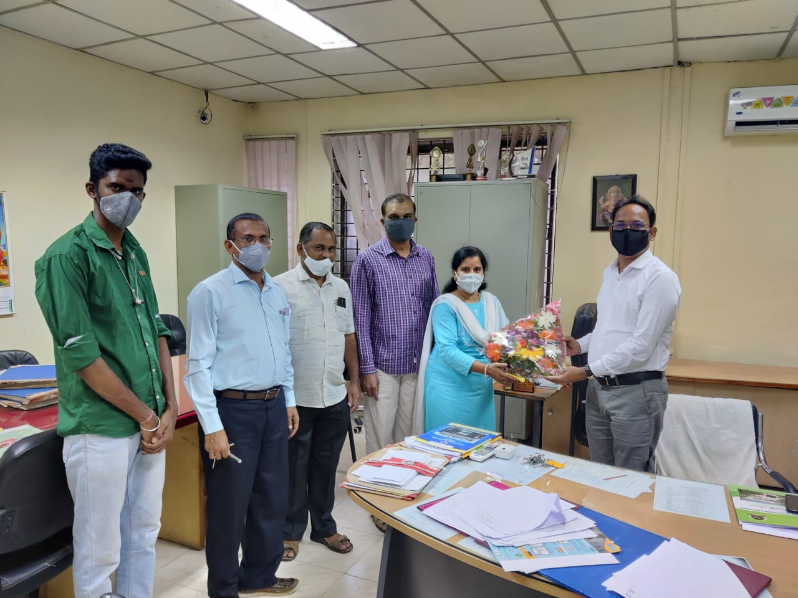

Students Placement Details:

- V.Navya Sree , Roll no 21011D1001 placed on Cyient L&T , Alstom, Bangalore. Package :7.5 per Annam.

- K.Chandana, Roll no 21011D1010 placed on MTAR Technologies, Hyd, 3.8. per Annam.
- K.Srinath , Roll no 21011D1016 placed on MTAR , Hyd, 3.8. per Annam.
- B.Venugopal ,Roll No. 21011D1008 plased on BOSCH , Bangalore.CTC:9 LPA.
- K. Srija ,Roll No. 21011D1011 plased on BOSCH , Bangalore.CTC:9 LPA.
- M.Shiva Prasad,Roll No. 21011D1003 plased on BOSCH , Bangalore.CTC:9 LPA.
- V. Santosh ,Roll No. 21011D1006 plased on Ilensys Technologies pvt ltd. Hyderabad.CTC:4.2 LPA.
- M. Shashi Kumar ,Roll No. 21011D1007 plased on Jocata , Hyderabad
.CTC:4 LPA.

