NEWS LETTER 2019-2020

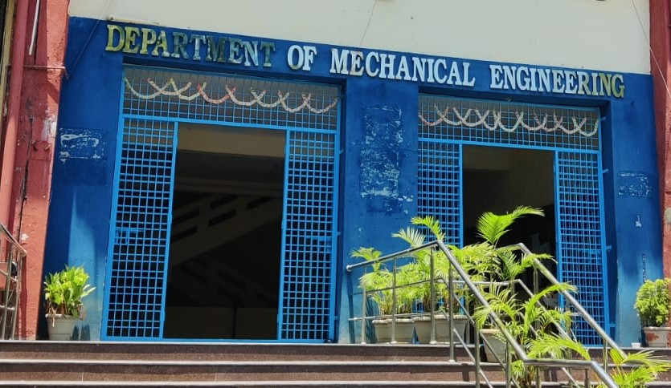

Center for Energy Studies
Department of Mechanical Engineering
JNTUH COLLEGE OF ENGINEERING HYDERABAD (AUTONOMOUS)
KUKATPALLY, HYDERABAD-500085.

FACULTY NAME DESIGNATION
Dr. Dr. M.T.Naik Professor & Coordinator
Dr. K. V. Sharma Professor

ASSISTANT PROFESSORS (CONTRACT)
Mr .G .Ravi
Mr. P.S. Vijay Sagar
TEACHING STAFF

NON-TEACHING STAFF

LABORATORY STAFF
Mr. G. Kanthaiah | Technical Assistant
ADMINISTRATIVE STAFF
G.Sreedevi |  | Computer Operator
N. Shashi Kumar |  | Attender

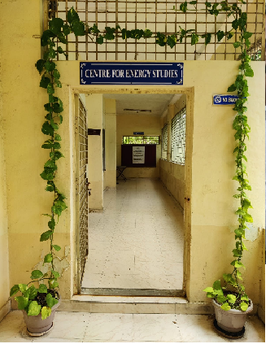
ABOUT THE CENTER FOR ENERGY STUDIES
Energy availability at economic cost is the driving force for any economy. In recent years, the growth in the industrial/service sector has resulted in enhanced energy consumption widening the gap between the energy demand and supply. Energy conservation has attained priority as it is regarded as an additional energy resource. A few organizations engaged in the field of energy studies confined their activities to the area of consultancy. Realizing this limitation, the School of Energy was established by the University in the year 1989.
Before starting the School of Energy, the University offered a five-semester part-time program in Energy Management. The academic Link Interchange scheme (ALIS) existed with the Scottish Energy Centre (SEC) at Napier Polytechnic, Edinburgh, U.K, in collaboration with the British Council Division, Madras. The outcome of ALIS was establishing the School of Energy in 1989 with the expertise of core faculty drawn from the constituent units of the University. The School of Energy commenced a 3-semester M.Tech program in Energy Systems in 1990. The school was later renamed the Center for Energy Studies (CES) in 1996. The Centre was brought under the administration of the College in 2003.

VISION and MISSION of the CENTER

- To provide quality education for graduate students by disseminating knowledge in inter disciplinary areas of science and technology
- To carry out both basic and applied research in solving diverse problems in energy sector
- To develop innovative measures leading to technology upgradation and energy conservation
- To undertake development, testing and transfer of technology to stake-holders for sustainable development
- Act as a nodal Centre for promoting sponsored research and industrial consultancy

FACULTY PROFILES
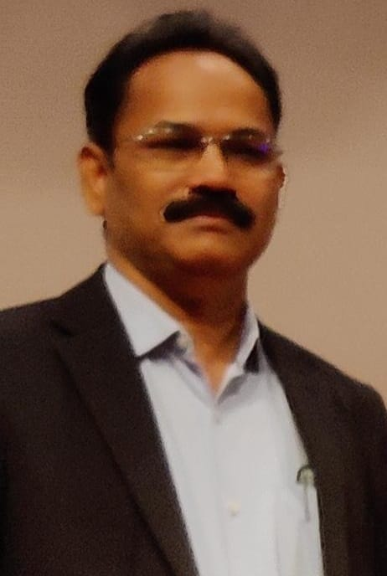
Dr. M.T. Naik
B. Tech, M.Tech, Ph. D
Professor
Prof.M.T.Naik completed his B.Tech, M.Tech and Ph.D in the Mechanical Engineering from Jawaharlal Nehru Technological University Hyderabad. He joined in JNTUH as Lecturer of Mechanical Engineering in the year 1994.He was promoted as Associate Professor in the year 2003 and since 2011 he has been working as Professor. His research areas include heat transfer in nanofluids, Renewable energy Technologies and optimization of Energy systems. He has published about60 research articles in reputed international Journals.He has h-Index score is 12 and more than 1000 citations for the research articles. He guided four Ph.D students and supervising four more research scholars.
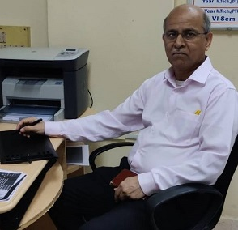
Dr. K.V. Sharma
ME (Andhra University), Ph.D (JNTU)
FIE, MISTE, ISHMT, HESI
Energy Systems
1. Ph.D in Mechanical Engineering, Jawaharlal Nehru Technological University, Hyderabad with First (1995-2000)
2. M.E in Mechanical Engineering, Andhra University with First (1982-1985)
3. B.Tech in Mechanical Engineering, Jawaharlal Nehru Technological University, Hyderabad with First (1977-1982)

NEW LABORATORIES EQUIPMENT
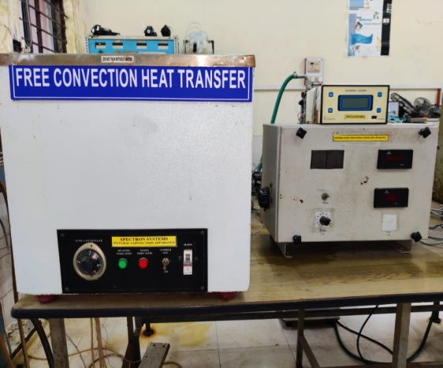

Solids and liquids gain or lose thermal energy when exposed to surrounding fluid which is at a higher or lower temperature. If the transfer of energy is not aided by an external source such as blowing or suction, the process of energy transfer is free convection. The experimental setup consists of a vertical heating element which is surrounded by a liquid such as water in an enclosure. The electrical heater loses heat to water by the mechanism of free convection. The rate at which heat is transferred to water is determined which is known as the free convection heat transfer coefficient.
Energy Conversation Lab
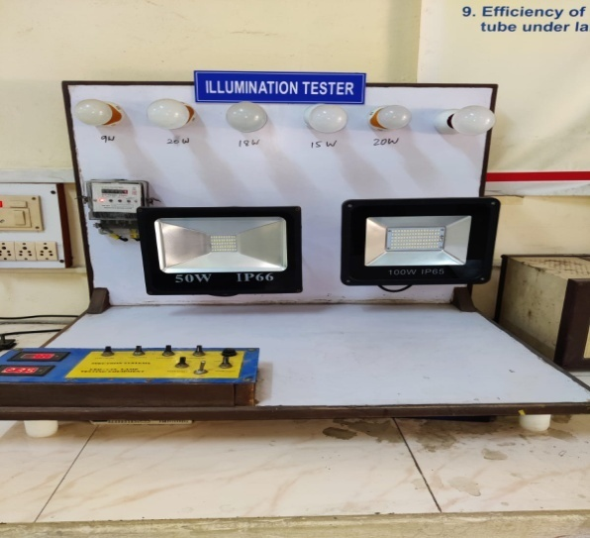
The amount of light that is cast on a surface is called illuminance, which is measured in 'Lux'. The total output of visible light from a light source is measured in lumens. One Lux is equal to one lumen per square meter. The further the light travels, the more it will be dispersed. The amount of lux in an area or on a surface can vary depending on the distance the light travels and the angle at which it is dispersed. Typically, more lumens a light fixture provides, the brighter it is. The setup is to demonstrate the conversion efficiency of the electrical energy into light form and to study the effect of distance from the light source.

WORKSHOPS AND SEMINARS
S.no | Title of the workshop | Resource Person | Dates
1 | Heat Transfer Enhancement and Energy Conservation Technologies | Dr. M. T. Naik | 29-11-2019

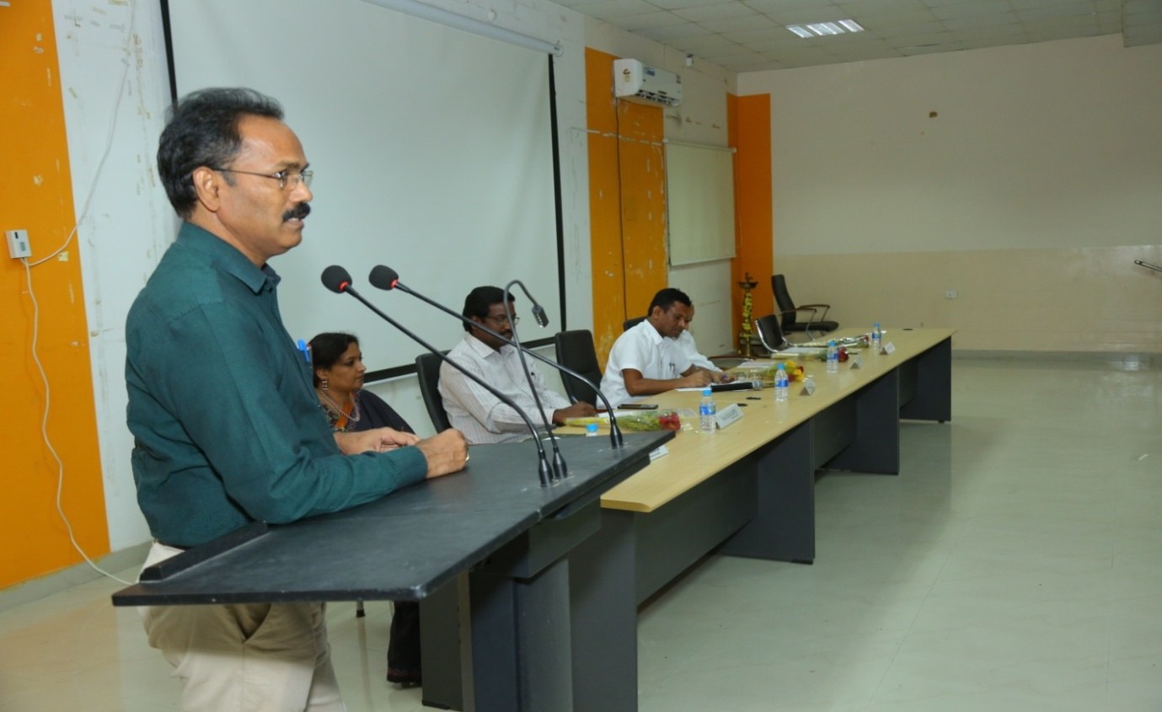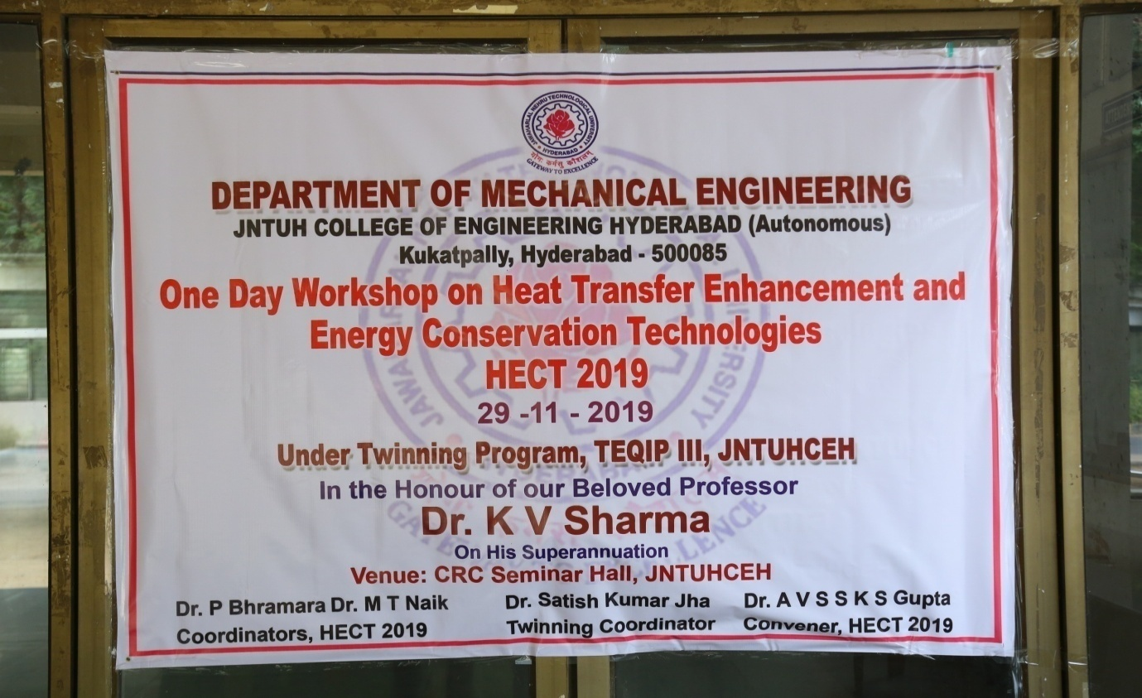
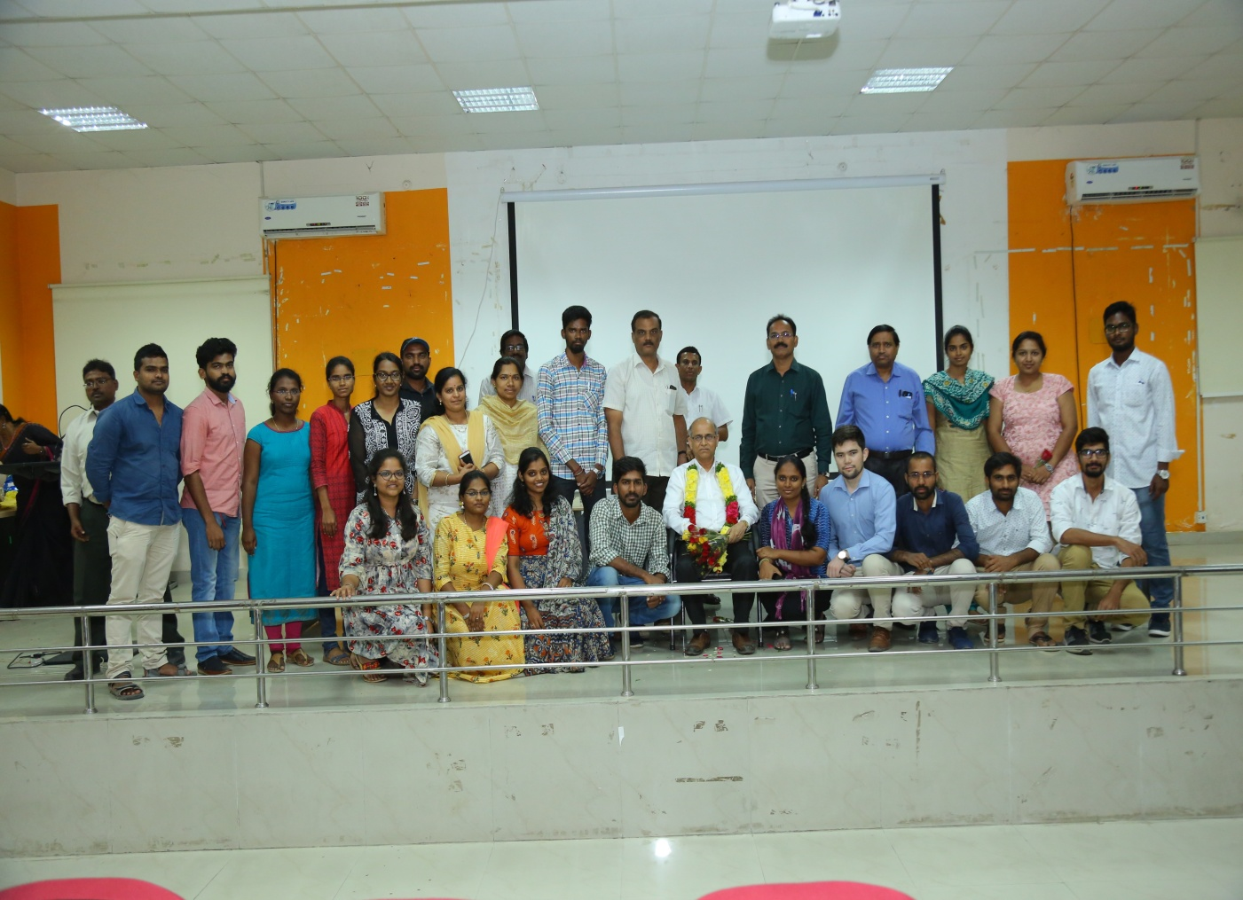

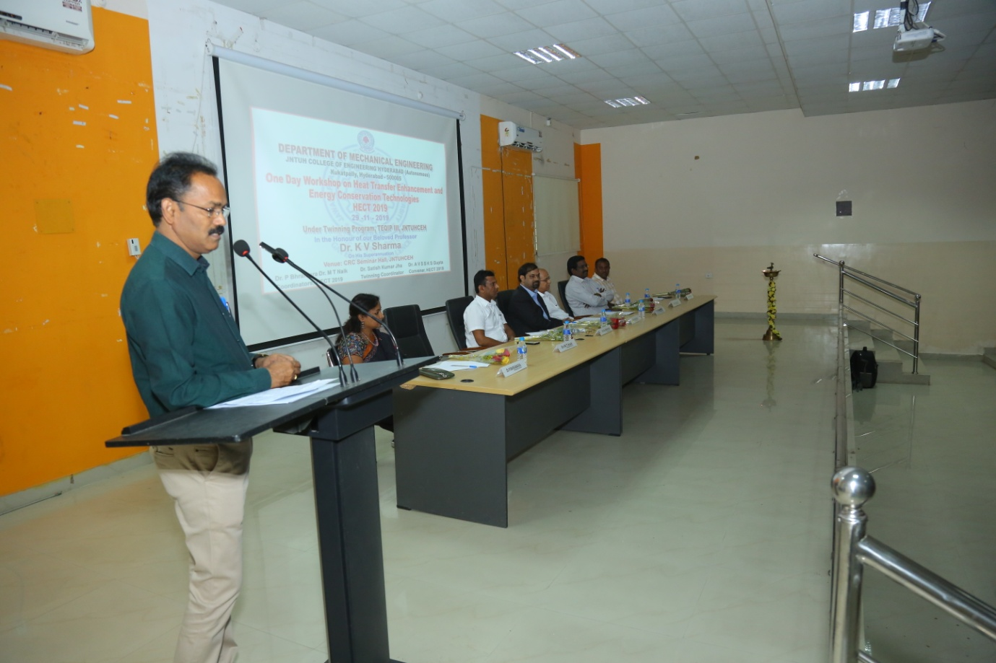
PUBLICATIONS
- Dr. M. T. Naik, “Influence of strain rates on forming characteristics of ASS316L sheets at elevated temperatures”’ Materials Today: Proceedings,2020. ISSN-2214-7853
- Dr. M.T.Naik “Comparative study of ASS 316L on formability at room temperature and super plastic region” Taylor & Francis, 18 Feb 2020, ISSN: 2374-068X.
- Dr. M.T. Naik, “Performance Improvement of Vertical Axis Wind Turbine With Airfoil Geometry”. AIJREAS) (April 2020) VOLUME 5, ISSUE 4 (2020, APR) ISSN-2455-6300.
- Dr. M. T. Naik, “Experimental Determination and Theoretical Prediction of Limiting Strains for ASS 316L at HotForming Conditions”, Journal of Materials Engineering and Performance”. May,2020, ISSN-1059-9495.
- Dr. M. T.Naik, “A comparative study on characterisation of ASS 316L at room and sub-zero temperatures” Advances in Materials and Processing Technologies”. Taylor & Francis, 2020 Jul 19. ISSN: 2374-068X
- Dr. M. T.Naik, “Enhancing the Low Wind Speed Performance of H- Darius Wind Turbine by Novel Methods”, International Journal for Modern Trends in Science and Technology(IJMTST) August 2020, ISSN: 2455-3778
- Praveen Kanti, K. V. Sharma, M. Revanasiddappa, C. G. Ramachandra, Suleiman Akilu, "Thermophysical properties of fly ash–Cu hybrid nanofluid for heat transfer applications", Heat Transfer Wiley, 2020;1–20, DOI:10.1002/htj.21837
- Praveen Kanti, KV Sharma, CG Ramachandra, M.Gurumurthy, “A CFD Study on fly ash nanofluid heat transfer behaviour in a circular tube, IOP Conference Series: Materials Science and Engineering.
- Praveen Kanti, K. V. Sharma, C. G. Ramachandra, BhramaraPanitapu, " Stability and thermophysical properties of fly ash nanofluid for heat transfer applications, Heat Transfer, Vol.49(8), 4722-4737, Wiley,2020;1–16, DOI:10.1002/htj.21849
- Seyed Reza Shamshirgaran, Hussain H. Al-Kayiem, Korada V. Sharma, Mostafa Ghasemi", State of the Art on Techno-Economics of Nanofluids-Laden Flat-Plate Solar Collectors for Sustainable Accomplishment", Sustainability
- Praveen Kumar Kanti, K.V. Sharma, C.G. Ramachandra, Munish Gupta, ThermalPerformanceofFlyAshNanofluidsatVariousInletFluidTemperatures: An Experimental Study, Int. Comm Heat Mass Transfer Vol.119 (2020) 104926
- Praveen Kanti, K. V. Sharma, C. G. Ramachandra, Alina Adriana Minea, “Effect of ball milling on the thermal conductivity and viscosity of Indian coal fly ash nanofluid”, Heat Transfer, Wiley,2020;1–16, DOI:10.1002/htj.21836 6|Page
- Seshu Kumar Vandrangi, Sampath Emani, Suhaimi Hassan, K.V. Sharma, Fluid dynamic simulations of EG-W (ethylene glycol-water) mixtures to predict nanofluid heat transfer coefficients, Environmental Technology & Innovation 2020
- Praveen Kanti, Viswanatha Sharma Korada, C.G. Ramachandra &P.H.V.SeshaTalpa Sai, "Experimental study on density and thermal conductivity properties of Indian coal fly ash water-based nanofluid, International Journal of Ambient Energy, https://doi.org/10.1080/01430750.2020.1751285
- Seshu Kumar Vandrangi, Suhaimi Hassan, Korada Viswanath Sharma, Suleiman Akilu, Sampath Emani, Narjes Nabipour," Effect of base fluids on thermophysical properties of SiO2 nanofluids and development of new correlations" Math Meth Appl Sci., Wiley,2020;1–19. DOI: 10.1002/mma.6535
- Korada Viswanatha Sharma, Seshu Kumar Vandrangi, LotfiSnoussi, Y. Raja Sekhar, MiladSadeghzadeh, Mohammad Hossein Ahmadi, “Influence of nanofluid properties on turbulent forced convection heat transfer in different base liquids" Math Meth Appl Sci., Wiley, 2020; 1–22. DOI:10.1002/mma.6386

CONFERENCE
- Dr. M.T.Naik, attended ”Recent Trends in Renewable Energy and Sustainable Development” ,Jan30,31-20220
