NEWS LETTER 2018-19

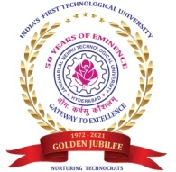
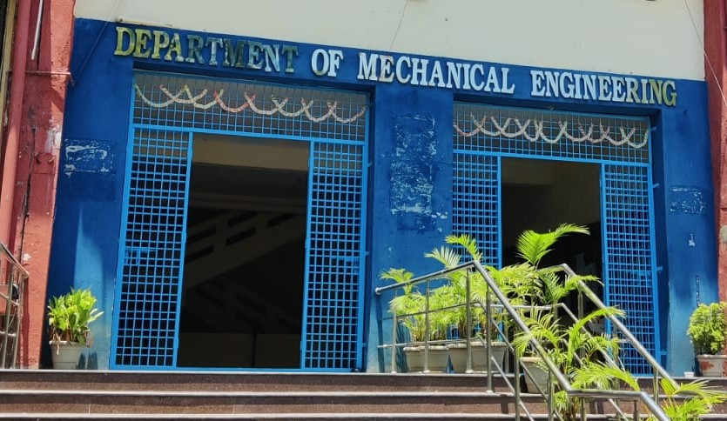

Center for Energy Studies
Department of Mechanical Engineering
JNTUHCOLLEGEOFENGINEERING HYDERABAD (AUTONOMOUS)
KUKATPALLY,HYDERABAD-500085TS.

FACULTY NAME DESIGNATION
Dr. A. Jaya Laxmi Professor & Coordinator
Dr. K. V. Sharma Professor
Dr. M.T.Naik Professor

TEACHING STAFF

ASSISTANT PROFESSORS (CONTRACT)

Mr. G.Ravi
Mr. P.S.Vijay Sagar

NON-TEACHING STAFF

LABORATORY STAFF
Mr. G. Kanthaiah | Technical Assistant
ADMINISTRATIVE STAFF
G.Sreedevi |  | Computer Operator
N. Shashi Kumar |  | Attender

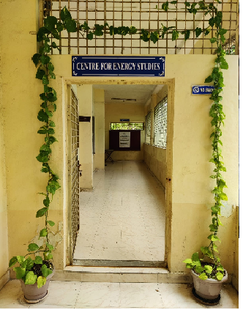
ABOUT THE CENTER FOR ENERGY STUDIES

Energy availability at economic cost is the driving force for any economy. In recent years, the growth in the industrial/service sector has resulted in enhanced energy consumption widening the gap between the energy demand and supply. Energy conservation has attained priority as it is regarded as an additional energy resource. A few organizations engaged in the field of energy studies confined their activities to the area of consultancy. Realizing this limitation, the School of Energy was established by the University in the year 1989.
Before starting the School of Energy, the University offered a five-semester part-time program in Energy Management. The academic Link Interchange scheme (ALIS) existed with the Scottish Energy Centre (SEC) at Napier Polytechnic, Edinburgh, U.K, in collaboration with the British Council Division, Madras. The outcome of ALIS was establishing the School of Energy in 1989 with the expertise of core faculty drawn from the constituent units of the University. The School of Energy commenced a 3-semester M.Tech program in Energy Systems in 1990. The school was later renamed the Center for Energy Studies (CES) in 1996. The Centre was brought under the administration of the College in 2003.

VISION and MISSION of the CENTER
- To provide quality education for graduate students by disseminating knowledge in inter disciplinary areas of science and technology
- To carry out both basic and applied research in solving diverse problems in energy sector
- To develop innovative measures leading to technology upgradation and energy conservation
- To undertake development, testing and transfer of technology to stake-holders for sustainable development
- Act as a nodal Centre for promoting sponsored research and industrial consultancy
FACULTY PROFILES
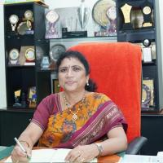
Dr. A. Jaya Laxmi
Ph.D Electrical Engineering JNT University, Hyderabad. Awarded degree in March 2007.
Professor and Coordinator
A. Jaya laxmi was born in Mahaboob Nagar District, Andhra Pradesh, on 07-11-1969. She completed her B.Tech. (EEE) from Osmania University College of Engineering, Hyderabad in 1991, M. Tech.(Power Systems) from REC Warangal, Andhra Pradesh in 1996 and completed Ph.D.(Power Quality) from Jawaharlal Nehru Technological University College of Engineering, Hyderabad in 2007. She worked as Coordinator, Centre for Energy Studies for 5 years 6 months.
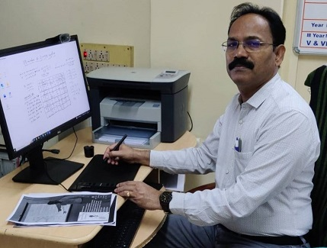
Dr. M.T. Naik
B. Tech, M.Tech, Ph. D
Professor
Prof.M.T.Naik completed his B.Tech, M.Tech and Ph.D in the Mechanical Engineering from Jawaharlal Nehru Technological University Hyderabad. He joined in JNTUH as Lecturer of Mechanical Engineering in the year 1994.He was promoted as Associate Professor in the year 2003 and since 2011 he has been working as Professor. His research areas include heat transfer in nanofluids, Renewable energy Technologies and optimization of Energy systems. He has published about60 research articles in reputed international Journals.He has h-Index score is 12 and more than 1000 citations for the research articles. He guided four Ph.D students and supervising four more research scholars.
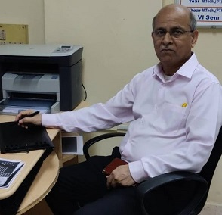
Dr. K.V. Sharma
ME (Andhra University), Ph.D (JNTU)
FIE, MISTE, ISHMT, HESI
Energy Systems
1. Ph.D in Mechanical Engineering, Jawaharlal Nehru Technological University, Hyderabad with First (1995-2000)
2. M.E in Mechanical Engineering, Andhra University with First (1982-1985)
3. B.Tech in Mechanical Engineering, Jawaharlal Nehru Technological University, Hyderabad with First (1977-1982)

NEW LABORATORIES EQUIPMENT
1 | Energy Conversion Lab
 | 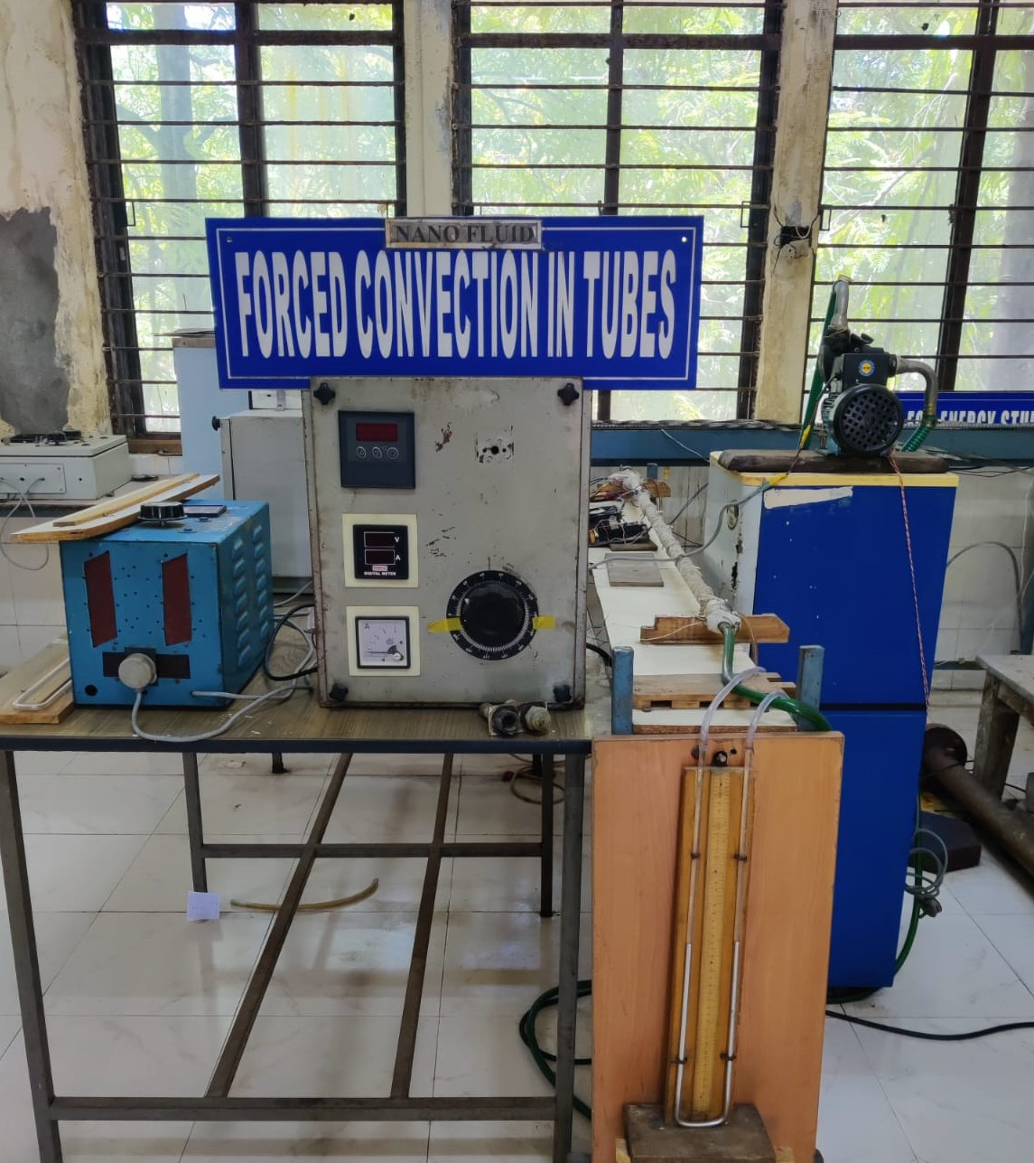

The fabricated experimental setup consists of a pump fitted to a copper tube for the liquid to flow in a horizontal orientation. The test section is covered with a flexible nichrome heater to a length of 1.2m. Three thermocouples are embedded on the tube wall, and two thermocouples are placed in the liquid stream, one at the entrance and another at the exit of the test section, to measure the temperature of the flowing liquid. The test pipe is connected to a manometer to determine the pressure drop across the length of the test section. Input to the heater is given through a dimmerstat. The flow rate of the liquid in the tube is measured with the aid of a measuring jar. A data logger is connected to the thermocouples to determine the temperature of the surface and the liquid. The Newton's law of cooling is used to estimate the local and hence the average heat transfer coefficients at various flow rates.

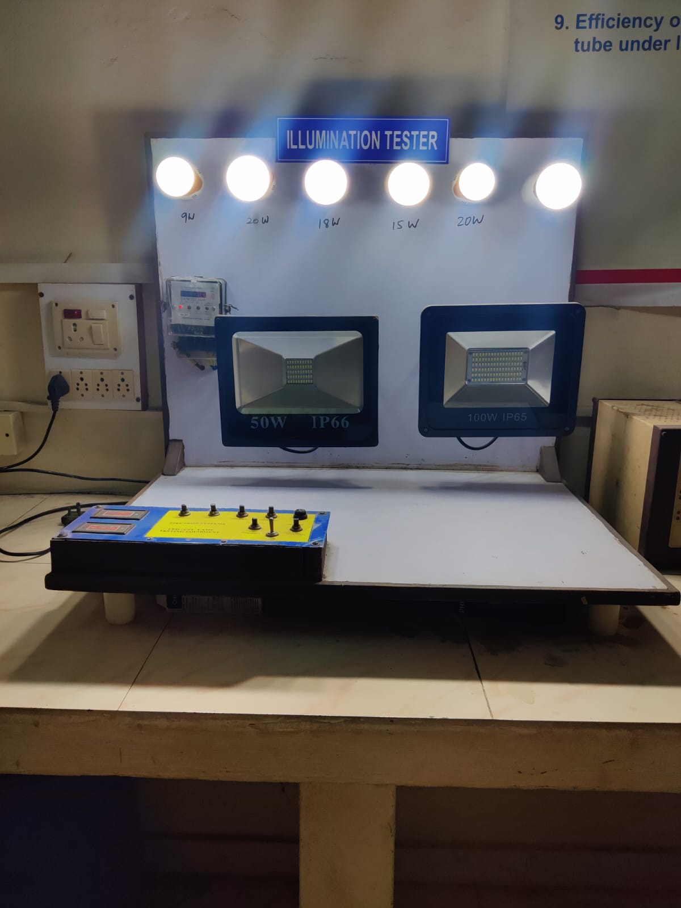
The amount of light that is cast on a surface is called illuminance, which is measured in 'Lux'. The total output of visible light from a light source is measured in lumens. One Lux is equal to one lumen per square meter. The further the light travels, the more it will be dispersed. The amount of lux in an area or on a surface can vary depending on the distance the light travels and the angle at which it is dispersed. Typically, more lumens a light fixture provides, the brighter it is. The setup is to demonstrate the conversion efficiency of the electrical energy into light form and to study the effect of distance from the light source.
PUBLICATIONS
- Dr. M. T. Naik, “A Comprehensive study and approach on Dissimilar Materials used in Welding process” Aveshanas International journal of Research in Engineering and applied science, ISSN- 2455-6300, 2019
- Dr. M.T.Naik “Experiment on GTAW of AL 6061-T6Material with SUS 304” International Journal of Recent Technology and Engineering (IJRTE),ISSN No. 2277-3878, 2019
- Dr. M.T. Naik, “A Review on Vertical Axis Wind Turbine Used for Household Applications” Journal of Emerging Technologies and Innovative Research, ISSN no- 2349-5162, 2019.
- Dr. M. T. Naik, “Experiment on GTAW of AL 6061-T6Material with SUS 304” International Journal of Recent Technology and Engineering (IJRTE)ISSN no. 2277-3878, 2019.
- Dr. M. T.Naik, “Evaluation and Optimization of Material properties of ASS316L at sub-zero temperature using Taguchi Robust Design”, Materials today Proceedings, ISSN no. 4475-4481, 2019.
- M.L.R. Chaitanya Lahari, P.H.V. SeshaTalpa Sai, K.S. Narayanaswamy, P. Haseena Bee S.Devaraj, K.V. Sharma, “Experimental determination of viscosity of Water-Glycerine based Cu nanofluids", Materials Today: Proceedings, 19 (2019) 517–520
- K. Abdul Hamid, W. H. Azmi, Rizalman Mamat, M. S. Mohamad, K. V.Sharma, “Numerical investigation for turbulent heat transfer of TiO2–SiO2 nanofluids wit wirecoilinserts,NumericalHeatTransfer:PartA,https://doi.org/10.1080/10407782.2019.1586425
- Suleiman Akilu, Aklilu Tesfamichael Baheta, Kumaran Kadirgama, Eswaran Padmanabhan, K.V. Sharma, “Viscosity, electrical and thermal conductivities of ethylene and propylene glycol-basedβ-SiCnanofluids”Journal of MolecularLiquids,Vol.284,15June2019,Pages780792,https://doi.org/10.1016/j.molliq.2019.03.159
- K. Abdul Hamid, W.H. Azmi, RizalmanMamat, K.V. Sharma, ”Heat transfer performance ofTiO2–SiO2 nanofluids in a tube with wire coil inserts”, Applied Thermal Engineering, Volume 152, April 2019, Pages 275-286, https://doi.org/10.1016/j.applthermaleng.2019.02.083
- Suleiman Akilu, Aklilu Tesfamichael Baheta, Kumaran Kadirgama, Eswaran Padmanabhan, K.V.Sharma, Thermophysical profile of SiC–CuO/C nanocomposite in base liquid ethylene glycol, Powder Technology, https://doi.org/10.1016/j.powtec.2019.04.061

