NEWS LETTER 2017-18

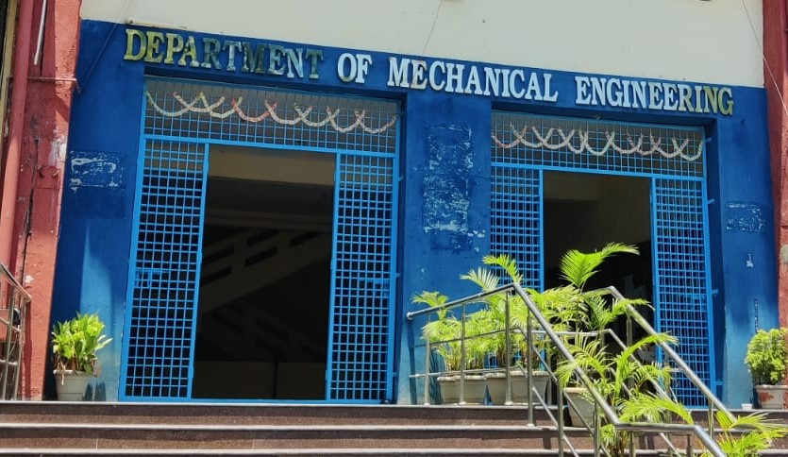

Center for Energy Studies
Department of Mechanical Engineering
JNTUH COLLEGE OF ENGINEERING HYDERABAD (AUTONOMOUS)
KUKATPALLY, HYDERABAD-500085

FACULTY NAME DESIGNATION
Dr. A. Jaya Laxmi Professor & Coordinator
Dr. K. V. Sharma Professor
Dr. M.T. Naik Professor
TEACHING STAFF
ASSISTANT PROFESSORS (CONTRACT)

Mr .G .Ravi
Mr. P.S. Vijay Sagar

NON-TEACHING STAFF

LABORATORY STAFF
Mr. G. Kanthaiah | Technical Assistant
ADMINISTRATIVE STAFF
G.Sreedevi | Computer Operator
N. Shashi Kumar | Attender

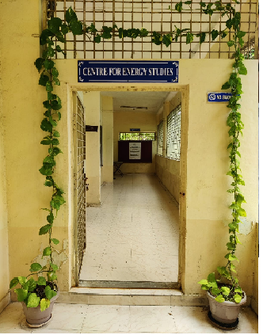

ABOUT THE CENTER FOR ENERGY STUDIES
Energy availability at economic cost is the driving force for any economy. In recent years, the growth in the industrial/service sector has resulted in enhanced energy consumption widening the gap between the energy demand and supply. Energy conservation has attained priority as it is regarded as an additional energy resource. A few organizations engaged in the field of energy studies confined their activities to the area of consultancy. Realizing this limitation, the School of Energy was established by the University in the year 1989.
Before starting the School of Energy, the University offered a five-semester part-time program in Energy Management. The academic Link Interchange scheme (ALIS) existed with the Scottish Energy Centre (SEC) at Napier Polytechnic, Edinburgh, U.K, in collaboration with the British Council Division, Madras. The outcome of ALIS was establishing the School of Energy in 1989 with the expertise of core faculty drawn from the constituent units of the University. The School of Energy commenced a 3-semester M.Tech program in Energy Systems in 1990. The school was later renamed the Center for Energy Studies (CES) in 1996. The Centre was brought under the administration of the College in 2003.

VISION and MISSION of the CENTER
- To provide quality education for graduate students by disseminating knowledge in inter disciplinary areas of science and technology
- To carry out both basic and applied research in solving diverse problems in energy sector
- To develop innovative measures leading to technology up gradation and energy conservation
- To undertake development, testing and transfer of technology to stake-holders for sustainable development
- Act as a nodal Centre for promoting sponsored research and industrial consultancy

FACULTY PROFILES

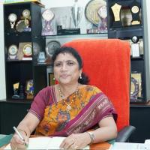
Dr. A. Jaya Laxmi
Ph.D Electrical Engineering JNT University, Hyderabad. Awarded degree in March 2007.
Professor and Coordinator

A. Jaya laxmi was born in Mahaboob Nagar District, Andhra Pradesh, on 07-11-1969. She completed her B.Tech. (EEE) from Osmania University College of Engineering, Hyderabad in 1991, M. Tech.(Power Systems) from REC Warangal, Andhra Pradesh in 1996 and completed Ph.D.(Power Quality) from Jawaharlal Nehru Technological University College of Engineering, Hyderabad in 2007. She worked as Coordinator, Centre for Energy Studies for 5 years 6 months.

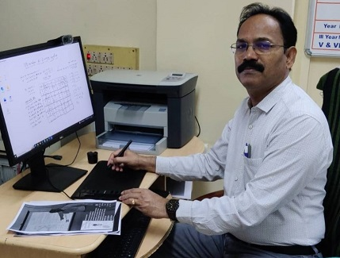
Dr. M.T. Naik
B. Tech, M.Tech, Ph. D
Professor
Prof.M.T.Naik completed his B.Tech, M.Tech and Ph.D in the Mechanical Engineering from Jawaharlal Nehru Technological University Hyderabad. He joined in JNTUH as Lecturer of Mechanical Engineering in the year 1994.He was promoted as Associate Professor in the year 2003 and since 2011 he has been working as Professor. His research areas include heat transfer in nanofluids, Renewable energy Technologies and optimization of Energy systems. He has published about60 research articles in reputed international Journals.He has h-Index score is 12 and more than 1000 citations for the research articles. He guided four Ph.D students and supervising four more research scholars.

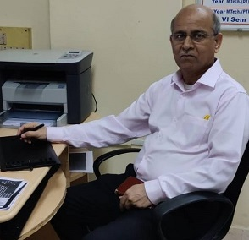
Dr. K.V. Sharma
ME (Andhra University), Ph.D (JNTU)
FIE, MISTE, ISHMT, HESI
Energy Systems
1. Ph.D in Mechanical Engineering, Jawaharlal Nehru Technological University, Hyderabad with First (1995-2000)
2. M.E in Mechanical Engineering, Andhra University with First (1982-1985)
3. B.Tech in Mechanical Engineering, Jawaharlal Nehru Technological University, Hyderabad with First (1977-1982)

Areas of Interest:
Single Phase Convection, Heat Transfer Enhancements with Nanofluids and Inserts, Computer Assisted Numerical Analysis, Numerical Simulation, Pool Boiling Heat Transfer, Solar thermal energy Conversion, Electronic Component Cooling, Packed Bed Heat Transfer, Heat Exchangers.

NEW LABORATORIES EQUIPMENT
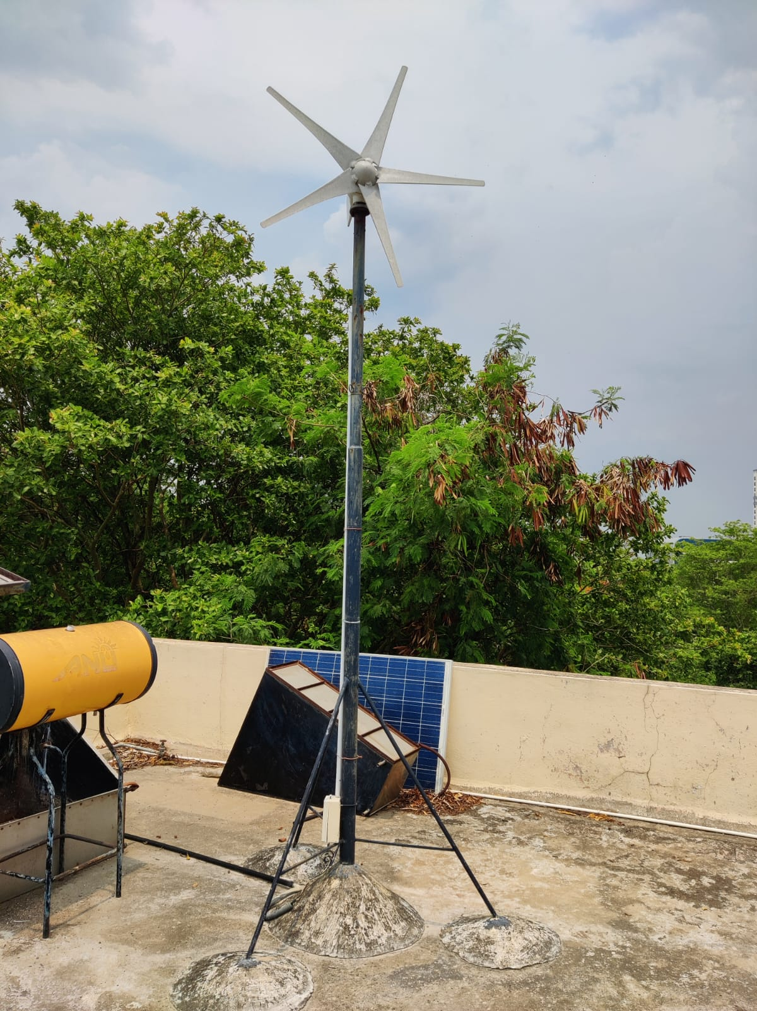

Wind energy is an indirect manifestation of solar energy. The main purpose of wind generator is to convert freely available wind energy into electrical form. The machine is five bladed, horizontally oriented which can generate a maximum of 200 W electrical energy. It is connected to a battery storage system with aids in its performance evaluation.
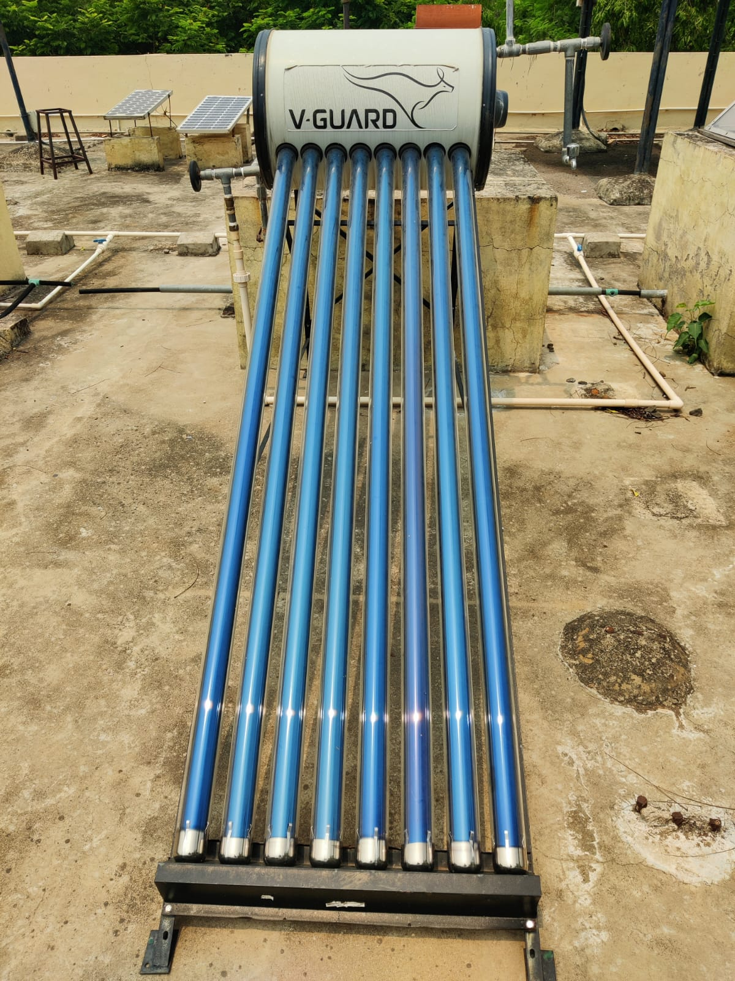

A double tube is the basic component of an evacuated tube collector. The material used for the outer tube is glass since it is transparent to solar radiation only but not to thermal radiation. In addition, glass holds vacuum better than the most other materials. Hence, glass is chosen as the material for inner tube also. A circular cross section is considered for the inner tube, which helps the weak glass to withstand the tension forces, produced in it by the pressure difference between the fluid inside and the vacuum outside. A suitable connection of an array of these tubes enables the collectors to receive both direct and diffused radiation.The performance of the collector is evaluated by recording the values of temperatures at the inlet and outlet of the evacuated tube at regular intervals and simultaneously noting the solar insolation on a horizontal surface using a pyranometer. The ratio of the energy absorbed by the tubes to the energy incident on the surface gives the instantaneous efficiency of the system.

PUBLICATIONS
- Dr. M. T. Naik, “A Prototype Model of Augmented Solar Tracking System for Electric Vehicles, International Journal of Control Theory and Applications ,International Science Vol No.10, Issue No.16, 2017, ISBN No.0974-5572
- Dr. M.T.Naik “A Comparative Study of Tensile Strength of Dissimilar Materials (SS 210,304,310, 316 And Mild Steel) Joined Using MIG and TIG Welding Process, International Journal of Multi-disciplinary Educational Research (IJMER), Vol.6, Issue.7, pp.95-109. 2017, ISSN : 2277-7881
- Dr. M.T. Naik, “Optimization of Process Parameters During TIG Welding of Si-Mg-Mn AL Alloy 64430”, International Journal of Mechanical and Production Engineering Research and Development (IJMPERD), Vol.8, Issue.3, pp.659-666.2018. ISSN(E): 2249-8001
- Dr. M. T. Naik, “A Review On Dissimilar Materials Welding Techniques” International Journal of Advancement In Engineering Technology, Management andApplied Science. (IJAETMAS), Vol. 5, Issue 01, pp. 111-123.2018, ISSN : 2349-3224
- Dr. M. T. Naik ,”A Comprehensive Study And Approach On Dissimilar Materials Used In Welding Process”. International Journal of Research In Engineering And Applied Sciences Vol.3, Issue.4, pp:230-234.2018, ISSN-2455-6300
- Dr. M. T. Naik “Study And Parameter Optimization Of Dissimilar Materials Using MIG Welding Process”. International Journal of Engineering and Techniques (IJET) Vol.4, Issue.2, pp: 1081-1085,2018. ISSN: 2395-1303
- Seshu Kumar Vandrangi, Sampath Emani, K.V.Sharma, GurunadhVelidi, “Computational analysis to determine the heat transfer coefficients for SiO2/60EGW and SiO2/40EGW based nanofluids," Annales de Chimie Science des Matériaux–Nov2018, DOI:10.3166/acsm.42.103-114,103-114.
- CHERECHES Elena Ionela, SHARMA K. Viswanatha, MINEA Alina Adriana, "A numerical approach in describing ionanofluids behaviour in the laminar and turbulent flow" 7|Page Continuum Mechanics and Thermodynamics, Continuum Mechanics and Thermodynamics, May2018,Volume30, Issue3, pp657–666. https://doi.org/10.1007/s00161-018-0634-x
- K. Abdul Hamid, W.H. Azmi, Rizalman Mamat, M.F.Nabil, K.V. Sharma "Experimental investigation of thermal conductivity and dynamic viscosity on nanoparticle mixture ratios of TiO2 -SiO2 nanofluids" International Journal of Heat and Mass Transfer116 (2018) 1143–1152
- S.R. Shamshirgaran, M.K. Assadi, H.H. Al-Kayiem, K.V. Sharma, “The role of nanomaterials in the enhancement of non-concentrating solar collector's technology", Materialwiss Werkstofftech. 2018, 49,435–441. 37.
- Suleiman Akilu, AkliluTesfamichaelBaheta, K.V.Sharma, Experimental measurements of thermal conductivity and viscosity of ethylene glycol-based hybrid nanofluid with TiO 2 - CuO/C inclusions", Journal of Molecular Liquids, Volume 246, November 2017, Pages 396- 405.
- Rama Krishna Konijeti, Pullela Kameswara Sarma, Naveen Puppala, K.V.Sharma, L.S.V. Prasad, ”A generalized correlation for the estimation of moisture removal in fruits and grains during warm air drying,” International Journal of Heat and Technology, Vol. 35, No. 2, June 2017, pp.426-432,p. 426-432DOI:10.18280/ijht.350228
- Seyed Reza Shamshirgaran, Morteza Khalaji Assadi, Korada Viswanatha Sharma,” Application of nanomaterials in solar thermal energy storage”, Heat and Mass Transfer / Warme-und Stoffuebertragung, DOI:10.1007/s00231-017-2259-1
- Seshu Kumar Vandrangi, Suhaimi bin Hassan, Sharma K.V., Prasad Reddy, “Comparison of nanofluid heat transfer properties with theory using generalized property relations for EGwater mixture” MATEC Web of Conferences 131, 03004 (2017) UTP-UMP SES 2017, DOI:10.1051/matec conf/201713103004
- S. Akilu, A. T. Baheta, K. V. Sharma, and M. A. Said, Experimental determination of nanofluid specific heat with SiO2 nanoparticles in different base fluids, AIPConference Proceedings1877, 090001 (2017); DOI:10.1063/1.4999896
- WH Azmi, NA Usri, Rizalman Mamat, K.V. Sharma, M.M.Noor, "Force convection heat transfer of Al2O3 nanofluids for the different based ratio of water: Ethylene glycol mixture"Applied Thermal Engineering112(2017)707–719.
- Pullela K. Sarma, Ramakrishna Konijeti, Tunuguntla Subramanyam, Lankapalli S.V. Prasad,Viswanatha S. Korada, Vadapalli Srinivas, Dharma R. Vedula, Veerapaneni S.R.K. Prasad, "Fouling and its Effect on the thermal performance of heat exchanger tubes, "International Journal of Heat and Technology, Vol.35, No.3, September 2017, pp.509-519.
- L. Syam Sundar, K.V. Sharma, Manoj K. Singh, A.C.M. Sousa, "Hybrid nanofluids preparation, thermal properties, heat transfer and friction factor – A review" Renewable and Sustainable Energy Reviews, 68, 185-198, 8|Page 2017.http://dx.doi.org/10.1016/j.rser.2016.09.108
- Gautam Edara, YVVSN Murthy, K.V. Sharma, Sunita Ho Pullela, Numerical Modelling of A Fuel Droplet For The Evaluation of Ignition Temperature Considering Transport Properties, Case Studies in Thermal Engineering, http://dx.doi.org/10.1016/j.csite.2017.05.001
- L. Snoussi, N. Ouerfelli, K.V. Sharma, N. Vrinceanu, A.J. Chamkha, A. Guizani (2017): "Physics and Chemistry of Liquids an International Journal" Numerical simulation of nanofluids for improved cooling efficiency in a 3D copper microchannel heat sink (MCHS),Physics and Chemistry of Liquids, DOI:10.1080/00319104.2017.1336237
- Suleiman Akilu, Aklilu Tesfamichael Baheta, Alina Adriana Minea, K.V.Sharma, Rheologyand thermal conductivity of non-porous silica (SiO2) in viscous glycerol and ethylene glycol-based nanofluids, International Communications in Heat and Mass Transfer, Volume 88, November 2017, Pages 245-253

AWARDS AND PRIZES RECEIVED BY THE STUDENTS

- Pappula Nancy Samyukta” Preliminary filtration of water invillages using silver coated clay potmaterial, A case study on Musi River-Village Edulabad. Mahatma Gandhi National Council of Rural Education ,Hyderabad. Development.

- Atyam Samhitha, Powering a village by generating energy from waste using biogas digester and microbial fuel cell (MFC). Discourse Initiated by Research for Resurgence Foundation

WORKSHOP
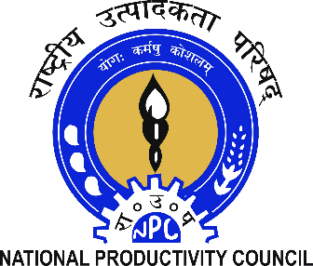

Energy Conservation Week Celebrations
14th – 20th December 2017
Workshop on “Energy Audit & Conservation”
At JNTUH

Schedule
Timing | Topic | Description
2:00 PM to 2:45 PM | Inauguration | NPC, JNTU & TSREDCO
2:45 PM to 3:45 PM | Best Practices in Oil Conservation | Mr. Rajesh Naik  Dy. Director, PCRA
3:45 PM to 4:15 PM | Energy Conservation Awareness | Mr. P. R. Rajkamal  Asst. Director, NPC
4:15 PM to 4:45 PM | Energy Conservation & Climate Change | Mr. P. Vinod Kumar  Asst. Director, NPC
4:45 PM to 5:00 PM | Vote of Thanks

Mr. Sh. Rajani Kanth
Director Gr-II,NPC ( Hyderabad )
